A1119-ME- Syria, Tell Brak (Nagar)-Eye-Idol-Rhombic-shaped (3500-3300 BCE)

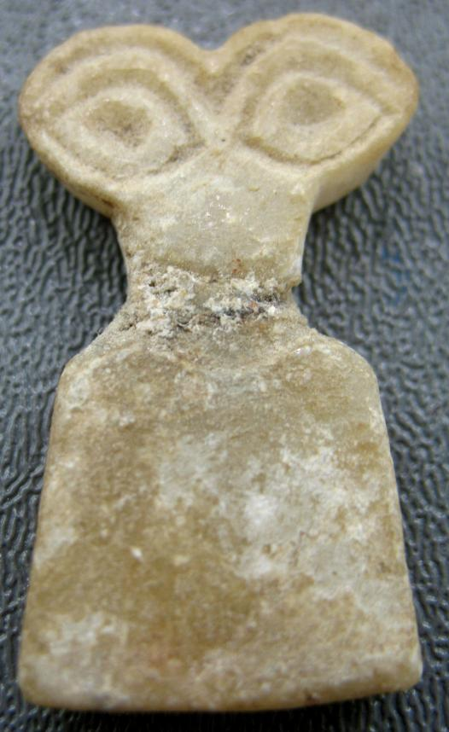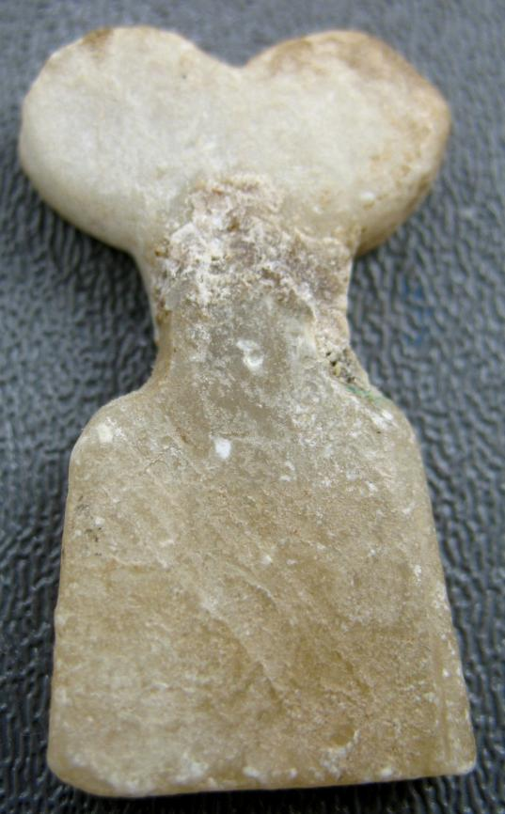

Figs. 1-2. Syria, Tell Brak (Nagar)-Eye-Idol-Rhombic-shaped (3500-3300 BCE)

**Case no.: 2**

**Accession Number:**

**Formal Label:** Syria, Tell Brak (Nagar)-Eye-Idol-Rhombic-shaped (3500-3300 BCE)

**Display Description:** Flat, Eye-Idol rhombic-shaped, tapering towards the top, without base so, presumably, it would have been set upright in sand in the temple precinct as a personal object of devotion. Its distinguishing feature is a pair of rhombic-shaped “eye” motifs set at a slightly oblique angles to each other. There are no perforations through the alabaster at the eye “motifs.” There are several sub-designs of this type involving multiple figures within an encompassing figurine base.

**LC Classification:** [DS99.B57](http://innovative.pts.edu/search?/cDS99.B57+E92+2003/cds+++99+b57+e92+2003/-3,-1,,E/browse)

**Date or Time Horizon:** 3500-3300 BCE

**Geographical Area:** Syria, Tell Brak (Nagar)

**Map, GPS coordinates:** 36.66833 41.05722;40° 26' 46" N 79° 58' 56" W

 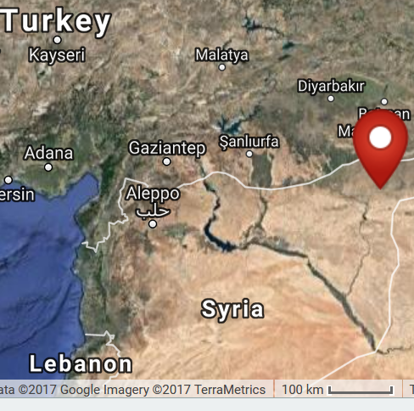

Fig. 4. Map with tells of ancient cities including Chagar Bazar and Tell Brak (Nagar) along irrigated rivers in n Syria extending s from Anatolia (Turkey).

**Cultural Affiliation:**

**Medium:** alabaster (gypsum).

**Dimensions:** H 1.5 in (3.8 cm).

**Weight:**

**Condition: original.** This example has a repair at the neck.

**Provenance:** Atlantika Collection.

**Discussion:** There are several sub-designs of this type involving multiple figures within an encompassing figurine base.

Because Tell Brak (Nagar) was located in the irrigated s margin of the Khabur plains, it controlled a large agricultural zone that provided produce for trade not only with local Ebla 280 km to the w but also with distant Sumeria to the ESE connected by tributaries with the Euphrates River trade (Akkermans and Schwartz 2003: 185). This connection with Sumerian cities (Ur, Uruk and Lagash) provides a clue as to the meaning of these Eye Idols, since the people in these cities worshipped Inanna, their most prominent female deity, who was equated with Tell Brak’s Ishtar (Ištar). The central characteristic of both deities was that they were ever watchful over their faithful worshippers. They could be characterized as deities with omniscient **Eyes** with which they scrutinized the lives of their believers and non-believers alike and meted out the fate of heaven to both, which is expressed in the following Neo-Sumerian hymn:

The skilled and beautiful one [Inanna], the delight of An [her father], the ornament of heaven,

She manifests like Moon at night,

She manifests like Sun at midday.

...

She renders an evil judgment to the Evil, She destroys the Wicked.

She gazes on the Faithful with resolute eye. She ordains a good fate for them.

From (Reisman 1969: 155, ll. 110-124). (Author’s own translation)

**References:**

Matthews, Donald M. 1997. *The early glyptic of Tell Brak : cylinder seals of third millennium Syria.* Orbis Biblicus et Orientalis, Series archaeologica, 15. Fribourg Switzerland: University Press; Göttingen: Vandenhoeck & Ruprecht.

Matthews, Roger. 2003. *Excavations at Tell Brak.* *Vol. 4, Exploring an upper Mesopotamian regional centre, 1994-1996.* Cambridge: McDonald Institute for Archaeological Research; British School of Archaeology in Iraq.

Oates, David; Joan Oates; Helen McDonald; Roger Matthews. 2001. *Excavations at Tell Brak. Vol. 2, Nagar in the third millennium BC*. Cambridge: McDonald Institute for Archaeological Research; British School of Archaeology in Iraq.

Reisman, Daniel. 1969. “Two neo-Sumerian royal hymns.” [Sumerian texts with English introduction, translations and notes] Ph.D. Diss., University of Pennsylvania.